

**PROJECT NAME**  : An Android Application for Keeping Up with the Latest Headlines

**TEAM MEMBERS** : 1. Samsani Srimaniteja

2.Sunkavalli Dheerendranadh

3.Telakalapalli Yuvavenkatateja

  4.Tummalapalli Nagalakshmikrishna

**TEAM ID :** LTVIP2023TMID05811

**An Android Application for Keeping Up with the Latest Headlines** :

The app's main feature is displaying a list of news articles, each with a title, image, and brief description. Users can scroll through the list of articles and tap on an article to view more details. The app uses the Jetpack Compose UI toolkit to build the UI and it uses the coil library to load images. The app fetches data from a remote server using Retrofit library and demonstrates how to use the Jetpack Compose UI toolkit for Android development.

**Learning Outcomes :**

By end of this project:

● You’ll be able to work on Android studio and build an app.

● You’ll be able to integrate the database accordingly.

● You’ll be able to integrate the API’s accordingly.

**Project Workflow:**

● Users register into the application.

● After registration , user logins into the application.

● User enters into the main page

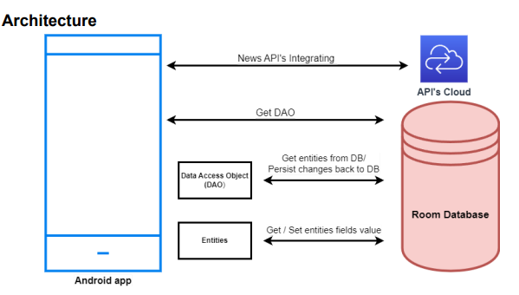

**Tasks:**

1.Required initial steps

2.Creating a new project.

3.Adding required dependencies.

4.Adding permissions

5.Creating the database classes.

6.Creating API Service and required classes for integrating API

7.Building application UI and connecting to database.

8.Modifying AndroidManifest.xml 9.Running the application.

**Task 1:**

Required initial steps :

**Task 2 :**

**Creating a new project**.

**Step 1** : Android studio > File > New > New Project > Empty Compose Activity

**Step 2** : Click on Next button.

**Step 3** : Give name to the new project.

**Step 4** : Give the Minimum SDK value

**Step 5** : Click Finish Main activity fil

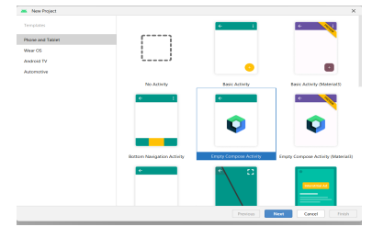

**Task 3 :**

**Adding required dependencies.**

**Step 1** : Gradle scripts > build.gradle(Module :app)

**Step 2** : Adding room dependencies. Add the below code in dependencies // Room Database implementation 'androidx.room:room-common:2.5.0' implementation 'androidx.room:room-ktx:2.5.0'

**Step 3** : Adding Retrofit dependencies // Retrofit implementation 'com.squareup.retrofit2:retrofit:2.9.0' implementation "com.squareup.okhttp3:okhttp:5.0.0-alpha.2" implementation 'com.squareup.retrofit2:converter-gson:2.9.0'

**Step 4** : Adding Coil dependencies

**Step 5** : Click on Sync now

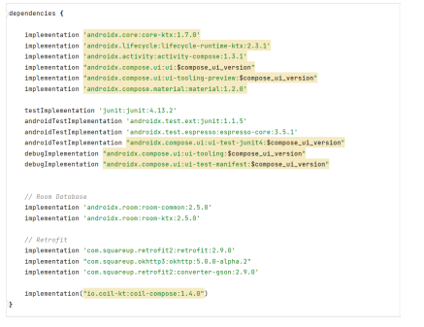

**Task 4:**

Adding permissions

**Step 1**: Open AndroidManifest.xml.

**Step 2**: Add permission to access wifi and internet

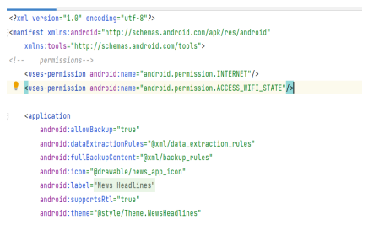

**Task 5**:

Creating the database classes

**Step 1** : Create User data class

**Step 2** : Create an UserDao interface

**Step 3** : Create an UserDatabase class

**Step 4** : Create an UserDatabaseHelper class

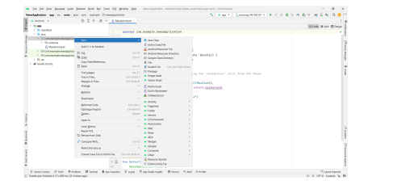

**Task 6 :**

Creating API Service and required classes for integrating API

**Step 1**: Create a API key for the required API

**Step 2**: Copy and paste the complete json file to json2kt.com

**Step 3**: Create ApiService interface

**Step 4**: Create Model data class

**Step 5**: Create News data class

**Step 6**: Create Source data class

**Step 7**: Create Articles data class

**Step 8**: Create MainViewModel class

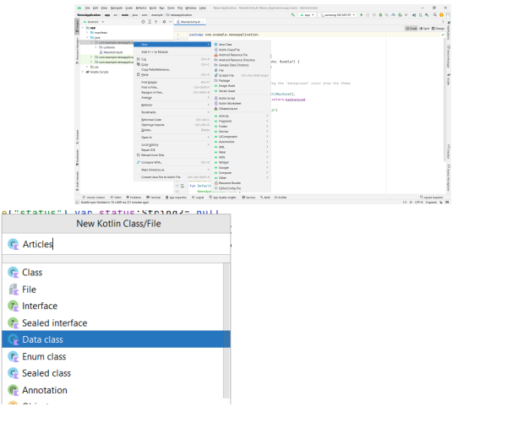

**Task 7**:

Building application UI and connecting to database.

**Step 1**: Creating LoginActivity.kt with database

**Step 2** : Creating RegistrationActivity.kt with database

**Step 3** : Creating MainActivity.kt file In MainActivity.kt file the main application is developed . Before creating UI we need to add some images in drawables which are in res

**Step 4** : Creating DisplayNews.kt file

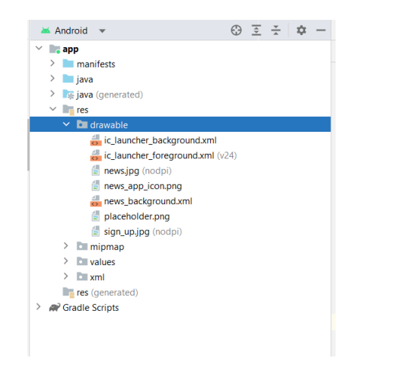

**Task 8:**Modifying AndroidManifest.xml

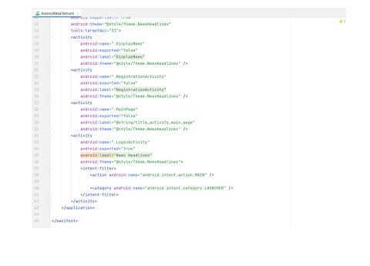

**Task 9:**

Running the application.

**Step 1**: Run apps on a hardware device

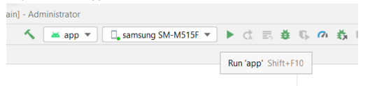

**Complete Project Link:**

**https://github.com/maniteja529/An-Android-Application-For-Keeping-Up-with-the-Latest-Headlines**

**Login Page:**

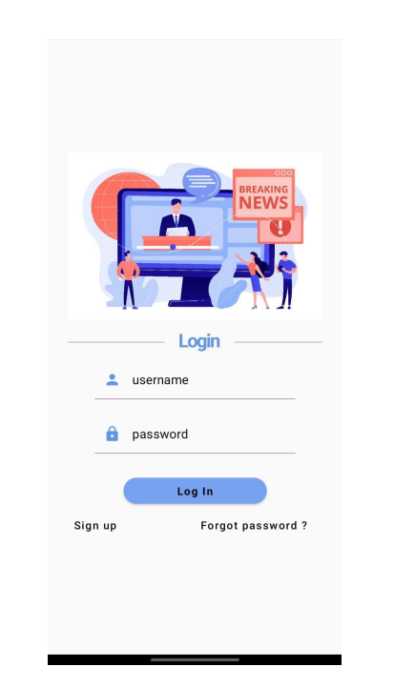

**Register Page :**

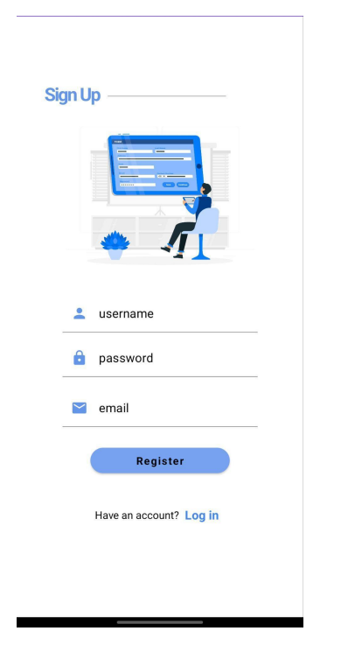



**Display News Page :**

